Artificial Intelligence and Machine Learning
Project Documentation format
1. Introduction
• Project Title: Deep Learning Fundus Image Analysis for Early Detection of Diabetic Retinopathy
•Diabetic Retinopathy (DR) is a diabetes complication that affects the eyes. Early detection is critical to prevent blindness.
Team Members:
Team ID : LTVIP2026TMIDS83275
Team Member: Meher Divakar – Model Development
Team Member: __________ – Data Collection & Preprocessing
Team Member: __________ – Frontend Developer
Team Member: __________ – Backend Developer & Testing Lead

2. Project Overview
Purpose:
This project uses Deep Learning techniques to detect and classify Diabetic Retinopathy (DR) from retinal fundus images. The goal is to assist ophthalmologists in early diagnosis, reduce manual screening time, and prevent vision loss through early intervention.

Features:
1. Intelligent Image Classification
The system uses Convolutional Neural Networks (CNN) to classify retinal images into:
- No DR
- Mild DR
- Moderate DR
- Severe DR
- Proliferative DR
It converts complex retinal patterns into accurate predictions.

2. Robust Image Preprocessing Pipeline
Includes:
- Image resizing (224x224)
- Normalization
- Noise reduction
- Pixel scaling
- Data augmentation (optional)
Ensures high-quality model input and improved accuracy.

3. Performance Optimization & Hyperparameter Tuning
Uses:
- Adam Optimizer
- Learning rate tuning
- Dropout layers
- Early stopping
- Batch size optimization
Reduces overfitting and improves generalization.

4. Comprehensive Evaluation Metrics
Model evaluated using:
- Accuracy
- Precision
- Recall
- F1-Score
- Confusion Matrix
- ROC-AUC Curve
Ensures reliable and validated model performance.

5. Scalable & Modular Architecture
Designed to integrate with:
- Web applications
- Hospital systems
- Cloud platforms
- Mobile health apps

6. Medical Decision Support
Provides:
- DR Stage
- Confidence Score
- Risk Level Indicator
Supports clinical decision-making (not replacing doctors).

7. Real-World Healthcare Applicability
System can be used in:
- Rural health camps
- Hospitals
- Telemedicine platforms
- Government screening programs

8. Extensibility with Future Technologies
Can be enhanced with:
- Real-time camera scanning
- Multi-disease detection
- Cloud deployment
- AI-based treatment recommendation

3. Architecture
Fig.1: Technical Architecture
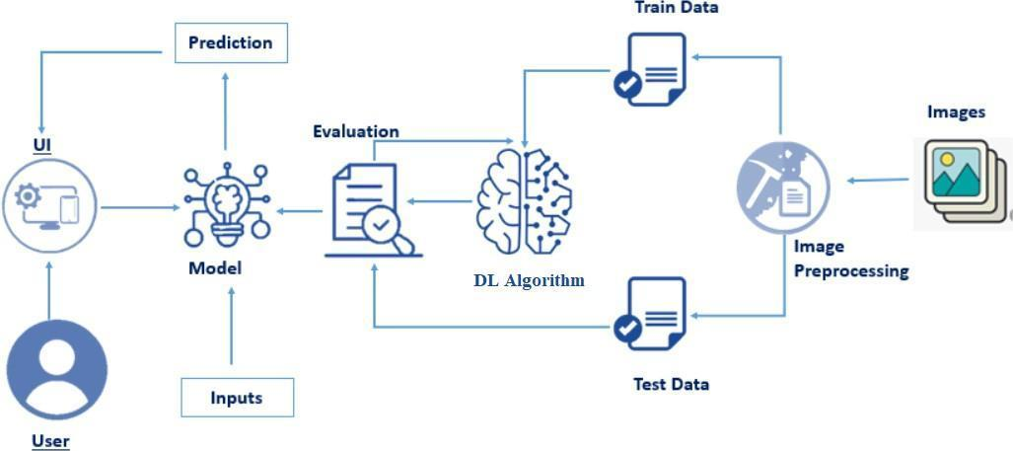

Overview of Technical Architecture
1. Data Layer
Retinal fundus images stored in dataset folder (Kaggle DR dataset).

2. Data Preprocessing Module
- Image resizing
- Normalization
- Data augmentation
- Train/Test split

3. Training and Testing Split
- Training Data (80%)
- Testing Data (20%)
Prevents overfitting and ensures proper evaluation.

4. Deep Learning Algorithm Layer
CNN Model:
- Convolution Layers
- Pooling Layers
- Dropout
- Fully Connected Layer
- Softmax Output
Model learns retinal lesion patterns.

5. Model Evaluation Module
Evaluates:
- Accuracy
- Confusion Matrix
- Classification Report
- Validation Loss

6. User Interface (UI) Layer
Web-based interface allows users to:
- Upload fundus image
- View prediction
- See probability score

7. Prediction Module
User uploads image → Model processes → DR stage predicted → Result displayed.

Architecture Flow:
Image Dataset → Preprocessing → Train/Test Split → CNN Model → Evaluation → Flask UI → Prediction

4. Setup Instructions
Prerequisites:
- VS Code
- Python 3.x

Installation:
Open terminal and install:
pip install numpy
pip install pandas
pip install tensorflow
pip install keras
pip install matplotlib
pip install seaborn
pip install scikit-learn
pip install opencv-python
pip install flask
pip install joblib

5. Folder Structure
Client (Frontend)
Templates Folder:
- index.html – Landing page
- predict.html – Image upload form
- results.html – Prediction results page
- adaptivity.html – Additional information page
Frontend collects image input and displays results.

Server (Backend)
- app.py – Flask application
- model.h5 – Trained CNN model
- requirements.txt
- static/
- templates/

Server Flow:
User Upload → Flask Backend → Image Preprocessing → CNN Model → Prediction → Result Display

6. Running the Application
1. Dataset Collection
Dataset downloaded from Kaggle DR dataset.

2. Exploratory Data Analysis (EDA)
Univariate Analysis
- Class distribution analysis
- DR severity frequency plot
Multivariate Analysis
- Severity vs Age
- Severity vs Image Features

3. Data Preprocessing
- Remove corrupted images
- Normalize pixel values
- Encode labels
- Split dataset

4. Model Building
CNN Model trained with:
- Adam Optimizer
- Categorical Crossentropy
- Epochs: 25
- Batch Size: 32
Evaluated using:
- Confusion Matrix
- Classification Report
- ROC Curve

5. Server-Side Application
Flask /predict route:
- Accept image upload
- Preprocess image
- Predict DR stage
- Return prediction + probability

7. API Documentation
Endpoint | Method | Description
/ | GET | Loads main page
/predict | GET | Loads prediction form
/predict | POST | Returns prediction via form
/api/predict | POST | Returns prediction in JSON
/adaptivity | GET | Loads information page

API JSON Example
Request:
{
"image": "base64_encoded_image"
}
Response:
{
"prediction": "Moderate DR",
"confidence": 92.4
}

8. User Interface
Fig.2 – Home Page
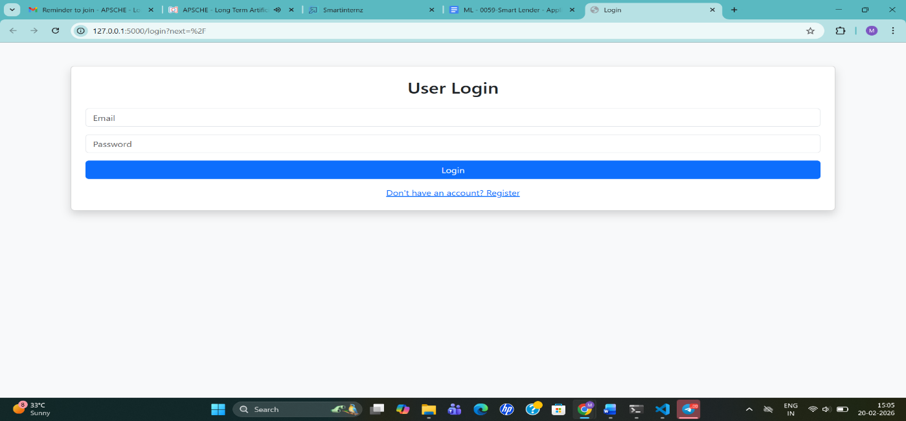
Fig.3 – Image Upload Page
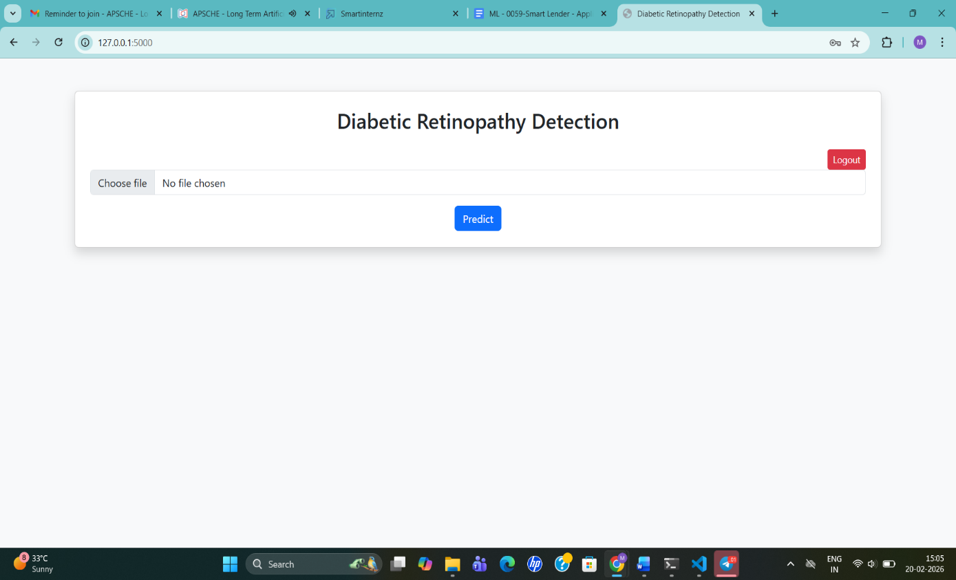

9. Testing
Testing Strategy
Functional Testing
- Verified routes
- Image upload
- Prediction output
API Testing
- JSON image input
- Error handling
Model Validation
- Checked class balance
- Verified prediction consistency

Tools Used
- Manual Browser Testing
- Postman
- Flask Debug Mode
- NumPy & TensorFlow

10. Screenshots / Demo
Fig.4 – Results Page

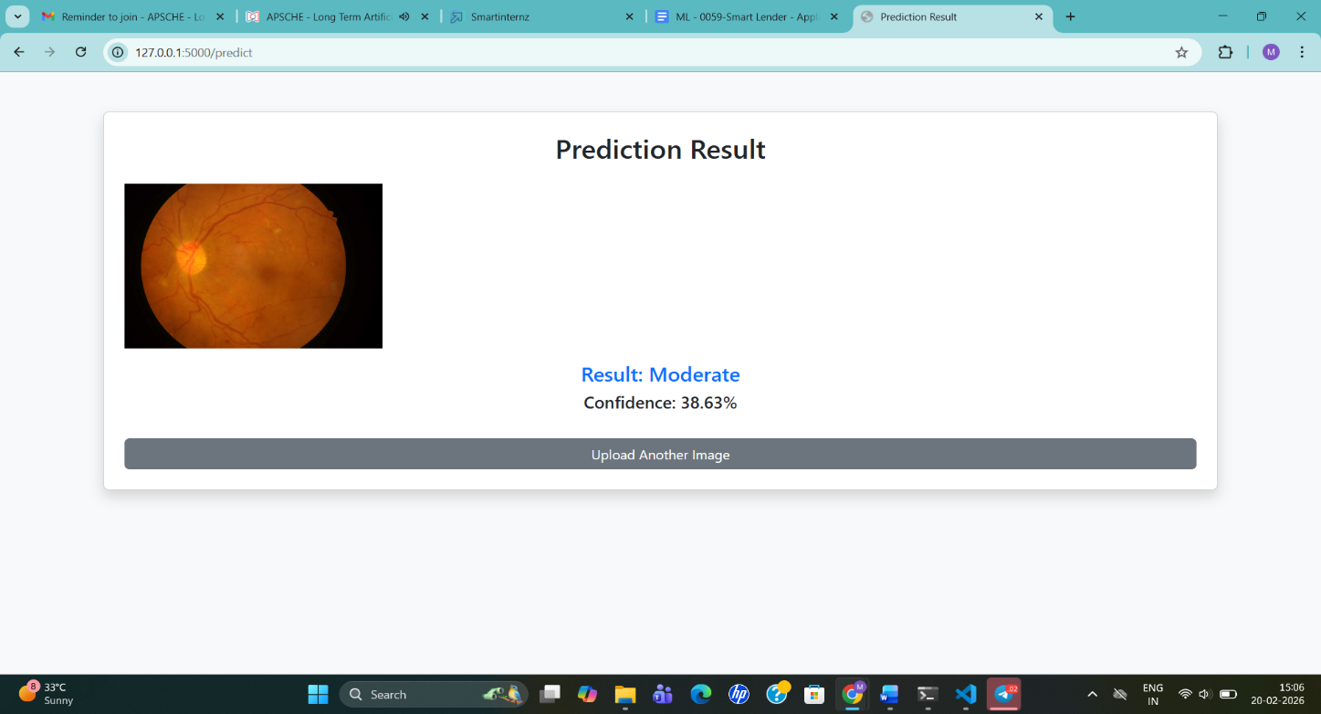

11. Known Issues
- Limited dataset diversity
- Slight overfitting risk
- Large image upload slows response
- Model interpretability limited (black-box issue)

12. Future Enhancements
- Add Grad-CAM visualization
- Deploy on cloud
- Add PDF medical report download
- Integrate doctor dashboard
- Multi-disease detection

--------------------------------------------------------------------------------------------------------------------------------------

1. Introduction
- Project Title: Deep Learning Fundus Image Analysis for Early Detection of Diabetic Retinopathy
- Context: Diabetic Retinopathy (DR) is a diabetes complication that affects the eyes, and early detection is critical to prevent blindness.
- Team ID: LTVIP2026TMIDS83275
- Team Member: Meher Divakar – Model Development & Lead
2. Project Overview
- Purpose: This project uses Deep Learning techniques to detect and classify Diabetic Retinopathy (DR) from retinal fundus images. The goal is to assist ophthalmologists in early diagnosis, reduce manual screening time, and prevent vision loss through early intervention.
- Features:
  - Intelligent Image Classification: The system uses the Xception architecture to classify retinal images into five stages: No DR, Mild, Moderate, Severe, and Proliferative DR.
  - Robust Image Preprocessing Pipeline: Includes image resizing to 229x229, normalization (rescaling by 1/255), and data augmentation such as 15-degree rotations and 0.15 zoom.
  - Performance Optimization: Employs transfer learning by freezing the base Xception model and unfreezing the last 10 layers for fine-tuning with an Adam Optimizer (learning rate: 0.000005).
  - Comprehensive Evaluation Metrics: The model is trained for up to 30 epochs with Early Stopping (patience of 5) to restore the best weights based on validation loss.
  - Scalable Architecture: Designed to integrate with web applications using a Flask-based modular backend.
  - Medical Decision Support: Provides the predicted DR Stage and a confidence score to support clinical decision-making.
  - Secure Authentication: Includes a user management system with encrypted registration and login using Flask-Login and SQLAlchemy.
3. Architecture
3.1 Overview of Technical Architecture
- Data Layer: Retinal fundus images are sourced from datasets and processed for model consumption.
- Data Preprocessing Module: Handles image resizing to 229x229, pixel normalization, and real-time augmentation.
- Machine Learning Algorithm Layer: Utilizes the Xception model with pre-trained ImageNet weights, a Global Average Pooling layer, and a 0.4 Dropout layer for final classification.
- User Interface (UI) Layer: A web-based interface built with Flask and HTML/Bootstrap templates for uploading images and viewing results.
- Prediction Module: Processes the user upload via the Flask backend to return the DR stage and probability score.
3.2 Architecture Flow
Image Dataset → Preprocessing → Xception Model → Evaluation → Flask UI → Prediction
4. Setup Instructions
- Prerequisites: VS Code or Anaconda, Python 3.9+.
- Installation:
  - Open terminal and run: pip install flask flask-login flask-sqlalchemy werkzeug tensorflow keras numpy gunicorn gdown.
  - Ensure the trained model dr_final_model.keras is in the project root.
  - Launch the application using python app.py.
5. Folder Structure
- Client (Frontend): templates/ folder containing index.html, login.html, register.html, home.html and prediction.html.
- Server (Backend):
  - app.py: Core Flask application and API routes.
  - final_model_training.py: Model fine-tuning and training logic.
  - dr_final_model.keras: Trained weights for inference.
  - static/uploads/: Storage for processed images.
6. API Documentation
Endpoint | Method | Description
/ | GET | Loads the main home dashboard (Login Required)
/login | GET/POST | Manages secure user authentication
/register | GET/POST | Handles new user registration with hashed passwords
/predict | POST | Accepts image, performs inference, and returns results
/logout | GET | Terminates the current user session
7. Testing Strategy
- Functional Testing: Verified all UI routes and the image upload pipeline.
- Model Validation: Confirmed prediction consistency and confidence scores for each of the five DR classes.
- Error Handling: Implemented checks for empty file uploads and automated folder creation for static/uploads.
8. Future Enhancements
- Deploy the system on cloud platforms (AWS/GCP) for global accessibility.
- Add Grad-CAM visualization to highlight pathological areas in the retina.
- Incorporate automated PDF medical report generation for patients.
- Expand to multi-disease detection including Glaucoma and Macular Degeneration.

